Hello

Once again, I write to you while the majority of us are still locked down: many of you tell me that you are desperate to get back to church and I echo that longing. For now, we are unable to go to our church buildings but we are still church: so what does that look like and what does it mean to us?

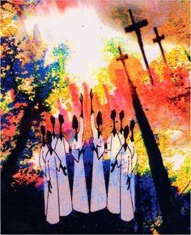
Our Zoom Bible study on a Monday night has been looking at gifts and at worship. We thought this week about a time of worship that really spoke to us; everyone could talk about a worship time that changed them and had a profound effect on their life.
Psalm 40:1&3
For the director of music. Of David. A psalm.

I waited patiently for the Lord;
he turned to me and heard my cry…..
He put a new song in my mouth,
a hymn of praise to our God.
Many will see and fear the Lord
and put their trust in him.

So what is worship and what is the church for? especially during this time. The start of this Psalm gives us some pointers.

Worship - The vertical dimension (up)
The psalm shows us that David had an experience with the Lord. God had rescued him and refreshed him. David had experienced the presence of God and had been changed by it. He couldn't be silent about his experience and sang praise to the Lord, saying: "He put a new song in my mouth, a hymn of praise to our God”. David was exuberant in song and praise. He was excited. He couldn’t contain his joy, his happiness, his relief. He had to shout and sing.
All of the Psalms were designed to be sung. Singing is an important spiritual expression that is mentioned explicitly 68 times in the Psalms.
And it wasn't just any song that David sang. It was a new song. There was a freshness and newness to his experience with God. It was as though he were seeing God again for the first time. He worshipped by singing a song of gratitude to God for who he was, what he said, and what he was doing. David knew that the source of his transformed life was God himself.

Worship The horizontal dimension (out)
As well as a vertical dimension to worship, there is also a horizontal dimension. David said, "Many will see and fear the LORD and put their trust in him.” Many were changed by seeing David praising; they would turn to God and find security in Him. Then they would join David in worship. David's joy before the Lord was an act of witness.
We don't worship just at church, because worship ought to be the constant attitude and activity of our lives as dedicated believers (I hope we have found this during the lockdown). But it is at church that we worship publicly and corporately. And, when the church gathers to worship, it also gathers to witness. Worship always includes witness.
When people who are far away from God hear people close to God in heartfelt praise to Him - when they see worship - they are intrigued. There is a mystery, a wonder. Questions are asked: How does that happen? Why does that happen? Sparks of fire from our worship can ignite dry hearts causing them to sing a new song and to praise God. Or at least it is my heartfelt prayer that this should happen.
But of course it can’t happen right now. And when we come back to worship we aren’t going to be allowed to sing in church because as we sing we expel breath more powerfully, so the risk of transmitting Covid 19 increases. This is terribly sad and difficult for so many of us but there is an upside to all of this.

During this time of lockdown we’ve been hearing about the number of people who have been googling about prayer and the large numbers of people who don’t normally go to church but who are accessing online worship services … colleagues have spoken to me about thousands of people accessing their services on line. Since I last wrote to you I’ve been praying about how we can be more present in our community during this time – should we do something online? I’m trying to find out how to edit audio files and what software is the best to use. But I’m not sure whether this is the right thing to do. I get anxious about downloading new things onto my computer in case something goes wrong and I wonder how many people would access online material. What do you think? Please would you let me know? And if you can help with the technology and putting it together.

As I mentioned last time, it is highly likely that, when we first come back to church, it will be for private prayer only. We had a very good PCC meeting (a virtual one of course) where we discussed how this might come about. A record of the discussion is on the last page of this letter, for your information. We spoke at length about the safest way to re-start church, it’s going to be a challenge and things aren’t going to be the same, but I will keep you posted.

I thought of something that we could do when the lockdown guidance is lifted further, in the period before we can go back to worshipping together inside the church buildings. It comes from the inspiration I have found in the new UK blessing song (on YouTube) which I have mentioned to you and which I know a number of you have found very helpful.

A thought occurred to me over the Pentecost weekend: when conditions allow could we sing out the UK blessing over Throckley and Newburn? We could gather – although two meters apart of course – outside St Mary’s and on the grass by the war memorial in Newburn. I’d bring my iPad and speaker (I’ve got a new speaker and I’ve practiced in the garden) and we could sing out the blessing to the community. As we would be looking out, our breath wouldn’t be going towards each other. When this idea came to me on Pentecost Sunday, I was excited. As it says in the Psalm ‘many would see’ and they would hear us. We wouldn’t be hidden behind stone walls we would be visible. A witness to God.

Anyway, please let me know what you think. You’d need to learn the song if you wanted to take part. I would need numbers so that I could manage the gathering…watch this space!

Another thing that I thought would be good for us to do during this time is to tell our faith stories. Some of us this did this for the Bishop’s Mission and really enjoyed trying to explain in two minutes how we became Christians. But this is not something that we should just do once – 1 Peter 3:15 urges us to be ready at all times to explain the faith that we have inside us.

As Christians we are called to tell others about the love of Jesus and about how he has transformed and continues to transform our lives. So I had a thought – why don’t we put a book of faith stories together? This could mean describing, as we did in the Bible study, a service in which God spoke to us. Or it could be our conversion story; the story of when we experienced God for the first time in our lives. Or it could be a time when we experienced a new filling of the Holy Spirit. But whatever people want to write about, it could be a book about how God worked in the lives of Christians in Newburn and Throckley. It would be great to put all these stories together into a book called ‘Newburn Parish Faith Stories’, to get it published and to have copies ready to give to people. It would be a blessing to us as we hear how God has worked and works in people’s lives and to others.

So, if you would like to be part of this, please consider writing your faith story. If you could aim for about 1,000 words, that would be great and if you could type it on the computer, that would help hugely with putting everything together. If people could volunteer to type any handwritten stories, or with the editing, that would be brilliant. Again I was really excited when this idea came to me and thought it was from God – but your response will tell me whether this is correct or not! If I don’t hear from you or only hear from a few I won’t take it further.

Finally to prayer, Linda Armstrong sent me some prayers and asked me to send them out to you, you might like to use them:

Thank God for the Bible and the Christian books that faithful people have written and which we can read at this time

Thank God for safety during dark times, for so much for good weather and for all those who have been taking care of each other

Thank God for those whose job is to care and who have risked their own safety for the sake of others

Thank God for Christian leaders – for Bishops, Deacons and Vicars – and pray for strength and rest for them.

Thank God for the church, which is his body.

As I’ve said throughout this letter we as the church need to be a blessing to others so enclosed is a blessing card which I would like you to colour in and give to someone in order to bless them. This is another small way where we can continue to be church even though we can’t meet together.
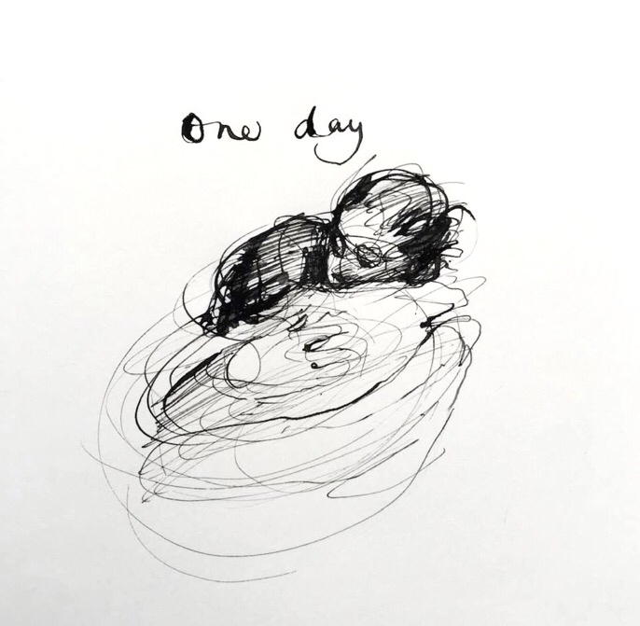

Love and Blessings

Charlie Mackesy.

I recommend Charlie Macksey book the “The Boy, The Mole, The Fox and The Horse”
I got it as a present for Christmas it’s wonderful.

Charlie described himself as atheist but……
At the age of 25, while strolling along in a London Park, Charlie had a feeling "that there must be more to this than meets the eye," "Jesus quietly introduced me to a journey into finding people really beautiful, which is how my art really began," said Charlie. The beginning of his faith journey, hopefully it inspires you to think about your own.

For your information an extract from the Informal PCC Minutes 12.5.2020 Phased Return

Allison reported that the Church of England is proposing a phased return to church.
We are in the first phase where Allison is currently allowed to go into church to pray. She is not doing this as Amanda and Elizabeth are going into church each week to check the fabric of the buildings. They would have to stop this if she went in.

The second phase is for the church to be open for personal and private prayer. Practicing social distance. We will need to open the church doors for an hour before this happens on the first occasion. The church will need to be cleaned after each time people have been in.
The third phase is that we would come back for worship but with no communion or singing and a deep clean afterwards. There can be no shared resources such as service books. There would probably need to be a one way system and use of sanitiser in the first instance. We would need to socially distance.

Allison noted that we needed to decide what to do and to complete a risk assessment for any plan. It is easier to deep clean St Michael’s than St Mary’s because of the wooden surfaces. It is very challenging to clean soft furnishings.

Jamie suggested that we should start in phase two by opening St Michael’s on a Sunday once this is allowed; Helen suggested that the church should be open from 9.30 to 12. We should ask people to come in for 15 minutes maximum. We could then see whether people wanted to have the church open at another time of the week. It was decided that people should be instructed to go into the main entrance of St Michael’s and turn right. They should then leave via the baptistry and out of the door near the coffee area. The doors would be fixed open so that people did not need to touch them. We would need entry and no entry signs, and a sign to say that people should not sit with anyone who is not part of their household. People would be asked to fill the church from the back and reminded as they came in that they must maintain social distancing.

Roz agreed to write a risk assessment for this phase two return. Allison would include a shortened version of the risk assessment in a letter to everyone. Jennie said that she would create a poster for the noticeboards. Allison suggested that we could ask people to put something on the Newburn and Throckley Facebook pages; Helen agreed to do this if Jennie emailed her the poster. Sainsburys and schools were other possible sources of publicity.

Elizabeth said she would look for materials to clean the church after each Sunday morning and Jamie said that he would add buckets to the family shopping list. However, it was agreed that we should use wipes in the first instance. Helen suggested that people could be given a wipe as they came in and asked to clean the area that they had sat in before they left; this would only leave the doors to be cleaned when everyone left.

Jennie agreed to do the signage if we needed to make our own. Amanda said she would look for any templates of signs that the government had produced for workplaces, and for something to cordon off the pews that were not to be used.

