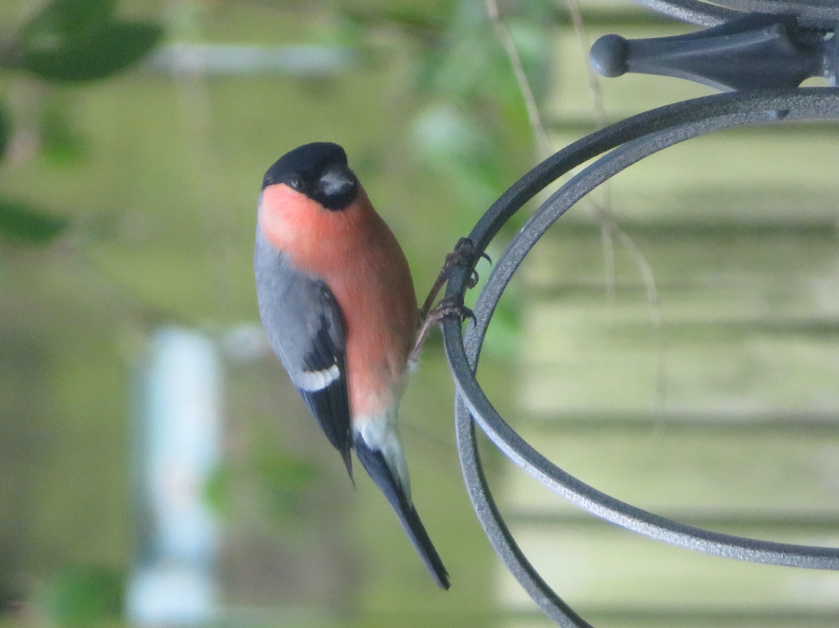
Hello

Firstly I hope you and your family and friends are well.

It is with a heavy heart that I have to write another letter and include readings for our daily prayer and virtual worship, because I had hoped that when we heard from Boris on the 10th May there would be more news about the way forward.

Instead we continue to be in lockdown for the foreseeable future and I have been thinking about parallels with the Bible – in particular the time when our Biblical ancestors (the Israelites) were in exile from their own land and then eventually returned. Ezra, Nehemiah and 2 Chronicles tell us that the Exile came about when the disobedient and rebellious people of God were driven out of their land by the Babylonians under King Nebuchadnezzar. Jerusalem and the temple were destroyed and almost all of the Israelites were forced to live in the land of Babylonia.

Books such as Isaiah were read by the Israelites as predicting that they would return in triumph to their former lands. When they did return, however, the reality was different. Babylon fell to Persia and Cyrus, the Persian king, issued a proclamation that the Israelites could return.

So the Israelites returned not as a conquering army but with the permission of a foreign ruler. The Book of Ezra states that 42,360 returned but this was by no means all of the Israelites – some had become comfortable in their life in Babylon and decided to stay where they were. When Ezra himself returned with some more of the Israelites, he was so distressed by the disobedience of the people to God that he threw himself to the ground. It was only when Nehemiah joined Ezra in God’s work that obedience to the law was restored, more Israelites returned and the re-building of the temple was completed. All this took many decades.

I’m confident that it won’t take many decades for us to return to worshipping regularly in Newburn Parish. But, like the Israelites, I am having to accept that the return to church will be nothing like I’d first hoped and thought it would be. While I don’t know exactly how it will turn out, I realise that it will bear no resemblance to my initial dream of a service where we invited all the community, remembered the dead and prayed for their families, and celebrated our freedom to worship and be together again. Instead, phase one is me being allowed into church to pray alone. Phase two is likely to be the church being open for private prayer with social distancing measures in place and deep cleaning afterwards. Phase three will probably be worship with a limited congregation, no singing or communion, strict social distancing, entering by one door and leaving by another, and the most vulnerable being asked to wait longer before coming back. For those PCC members who can get onto Zoom, we are having a virtual meeting to discuss the return further, but we must be ready for it to take a number of months.

All this has come as a huge disappointment to me, as I’m sure it will to you. I am certain that I’m not the only person who hoped for a day when there were no new covid-19 cases and we could enjoy doing all the things that we did before the lockdown. But that turned out to be false hope and so I must again look for the blessings that we have in our current times, while preparing for a very slow and gradual return to worshipping together. I’m hoping that we will eventually live a bit like before but that some things will be different and better, as we have had time to reflect and found new ways to do things.

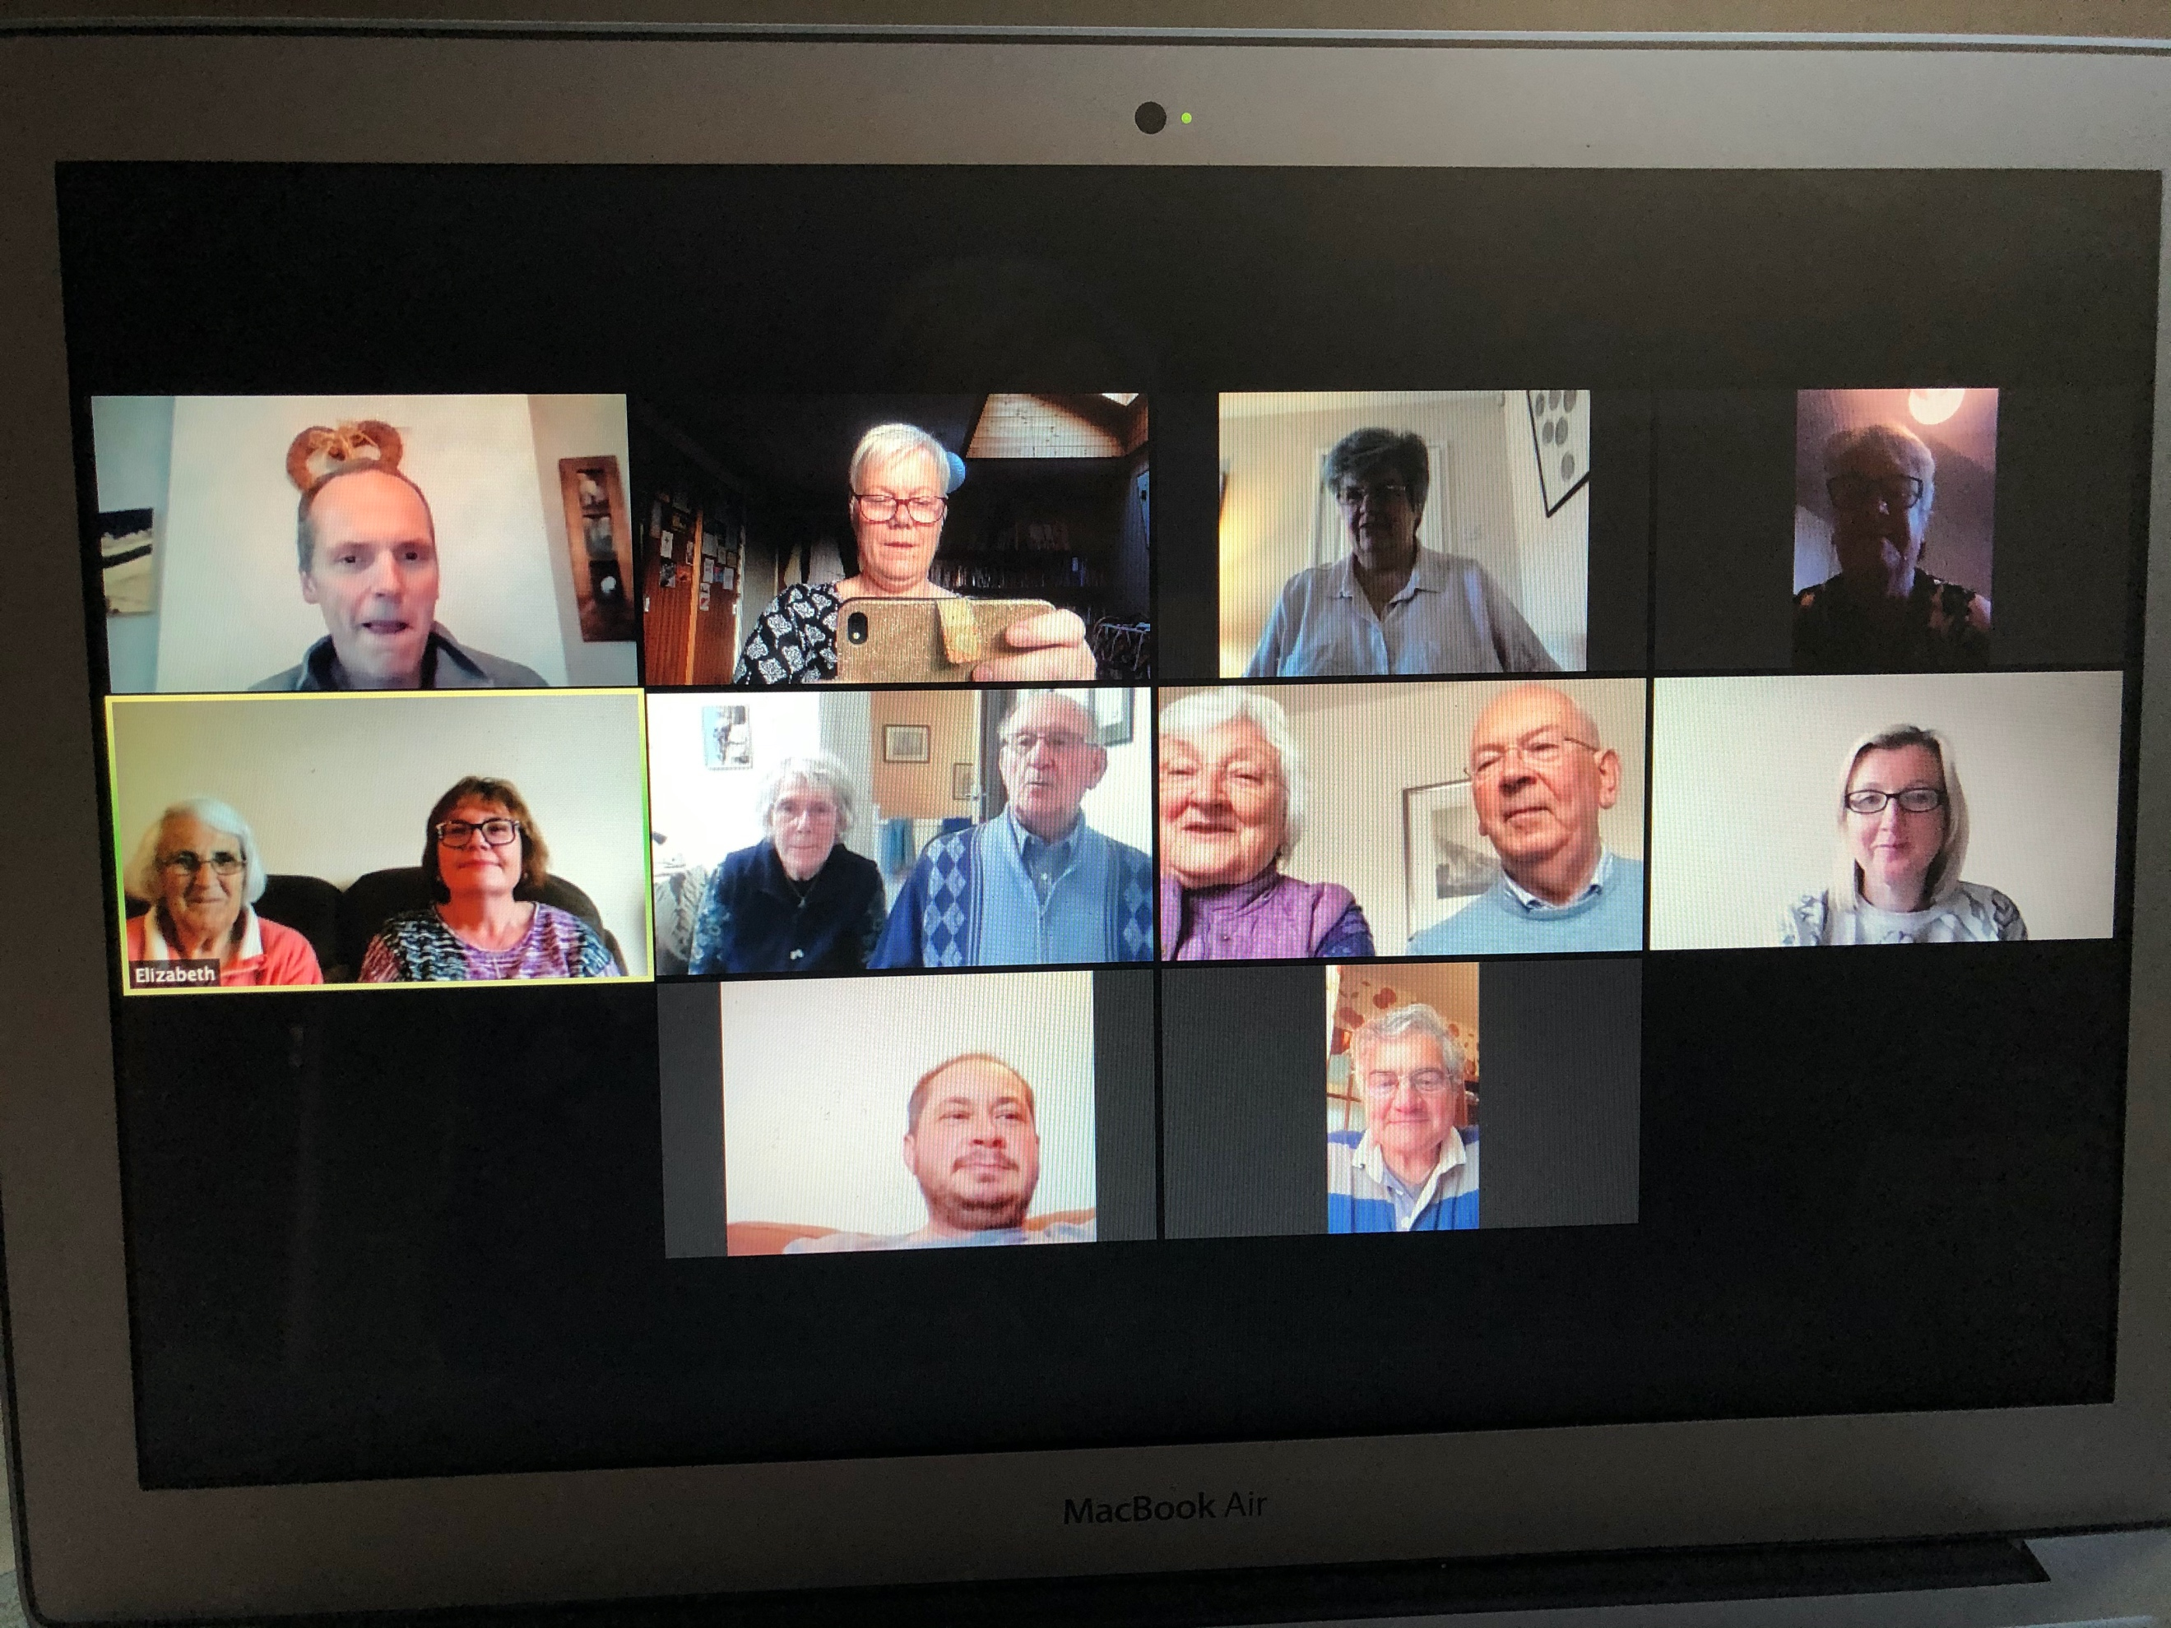
So, counting blessings again and some notices. I know that many of you are enjoying our Saturday morning services and the Sunday morning services on the BBC. I know some of you, like Jamie and I, have also joined in with a number of different services online. We’ve started a zoom Bible study on Monday evening : please let me know if you would like to join in with this. All you need is an email address and a smart phone, tablet or computer.

I know that many of you can’t access the resources that are available online, but the Church of England has a freephone number that offers music, prayers and reflections as well as a full worship services at the end of a telephone line. It’s called Daily Hope and the number is 0800 804 8044. You might like to give this a try.

At a Zoom meeting of clergy in the area, I was very proud – no, that’s sinful – I was absolutely delighted that the vicar in Benwell told everyone how much we had raised for the foodbank. This was a great effort by everybody and I have received further donations since. If you haven’t given to the foodbank and would like to, please get some cash to me or tell me how much you would like to give and we will arrange to get it to them. Lots of you who still owe me some money are getting a bit anxious about getting the money to me, you can wait until I see you or pop some money through the door on you daily exercise routine.

If you can get online, I recommend to go onto YouTube and listen to the UK Blessing, which was written by Tim Hughes. It’s lovely and a real blessing; have some tissues as I’ve seen it loads and it make me cry every time.

It’s Christian Aid week this week, if you usually give to them, please go online and make a donation at www.caweek.org (or you can send a cheque). Or, if you like, we can have a cup of coffee and a cake after our virtual service on Saturday morning and make a donation so we have a virtual coffee morning. Again I’m happy to send in a donation on behalf of the church with all the money that people have given. Anyway let me know what you think about this idea.

Please remember, if you haven’t done so already, do draw round your hands, make a cut out, decorate them and keep them safe. Whenever the day is that we can all be in church together, I will ask you all to bring the hands with you.

I’ve put some photographs in the letter that I’ve taken since lockdown, of visitors to the garden and the lovely bluebells and wild garlic in the Dene that I’ve seen while out and about. I usually copy something off the internet but this time I thought I’d send you something of my own..

Below are a list of the names of people I have conducted a funeral for please remember their families in your prayers:
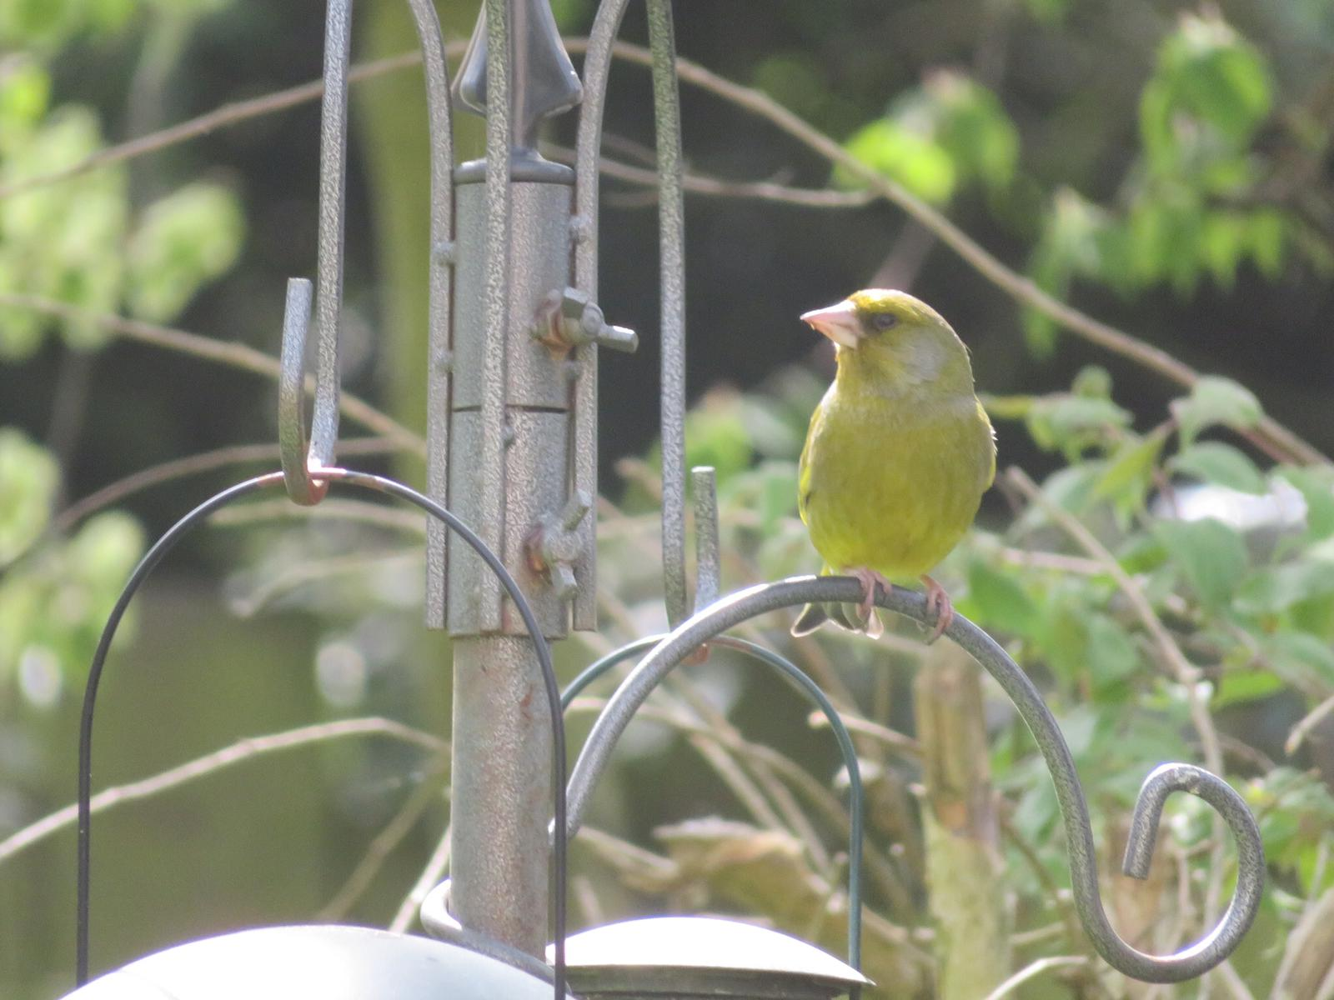
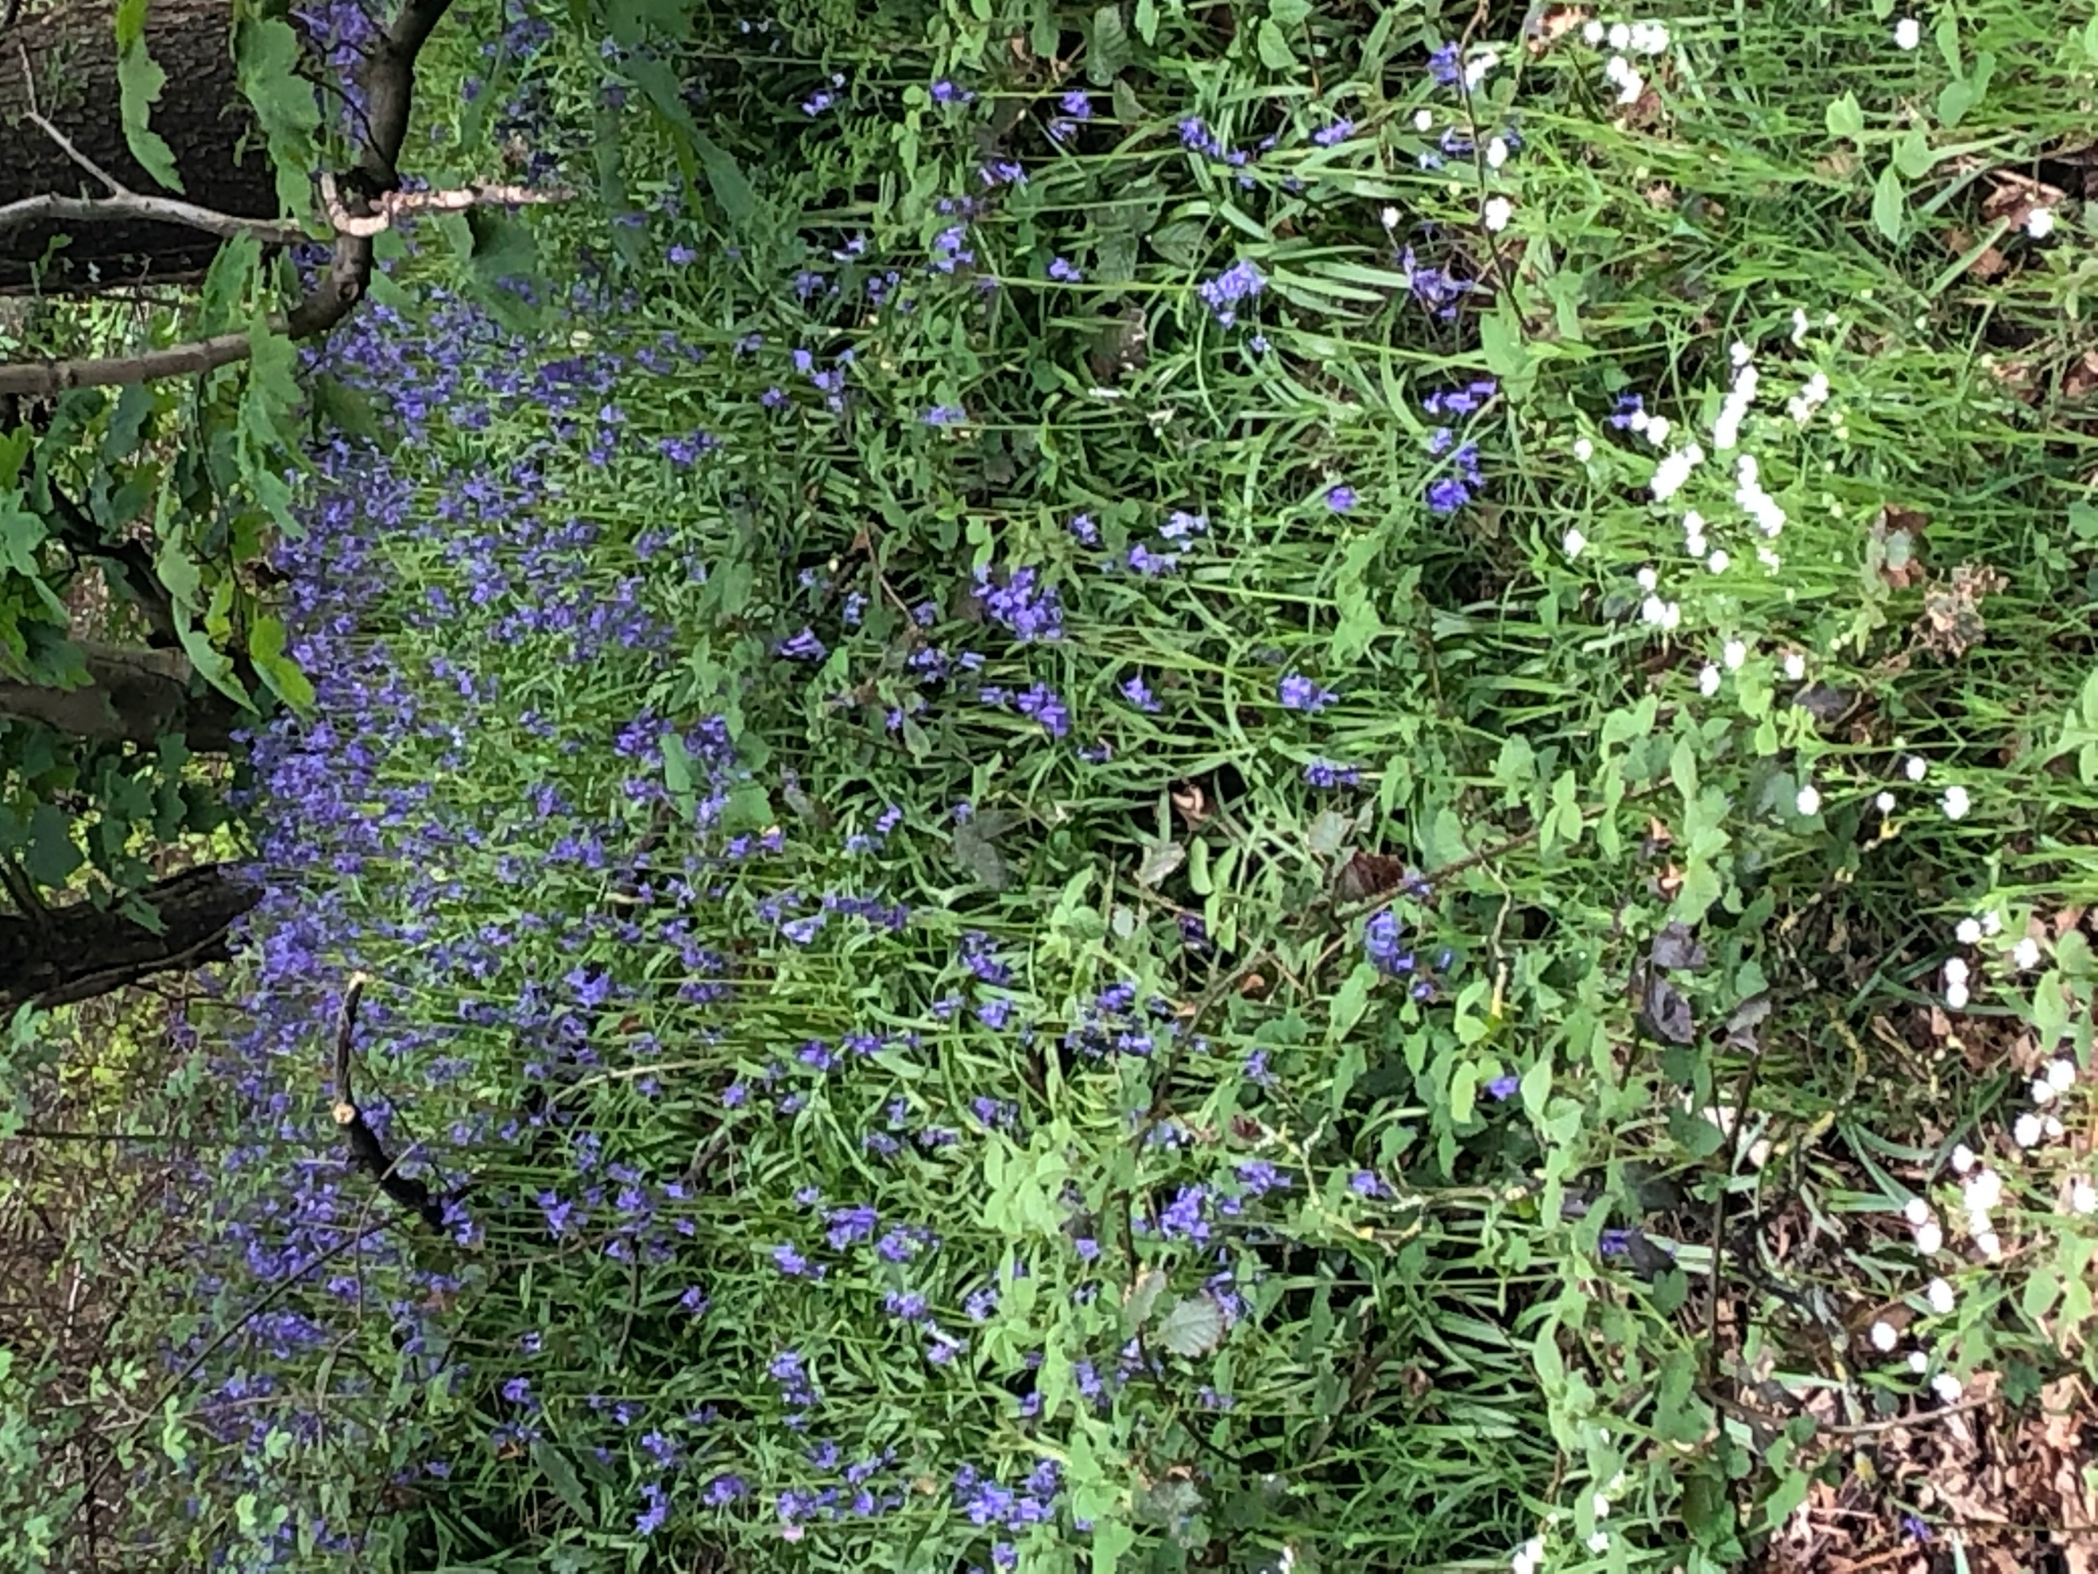
Margaret Clark 88yrs
Steve Bowers 68yrs (Margaret Bowers husband)
Belle Elsender 87yrs
Una Thompson 83yrs
Alan Davison 90yrs (Hilary Skoyles dad)
John Gray 95yrs

Take Care
^{Psalm 96:11-12 (NIV)}
Let the heavens rejoice, let the earth be glad;
let the sea resound, and all that is in it. Let the fields be jubilant, and everything in them;
let all the trees of the forest sing for joy.

Love Allison xx

