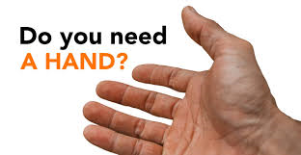
......... you or someone you know ?

IF YOU ARE SELF-ISOLATING, WE CAN HELP !
Do you need - shopping - a prescription picking up
- mail posted
- a friendly phone call
Please call Revd Allison Harding 0191 229 0522
who will put you in touch with one of the volunteers who will be able to help you. They will take every precaution as they assist you by ensuring regularly washed hands, avoiding physical contact and leaving goods on your doorstep.

ST MICHAEL’S NEWBURN & ST MARY’S THROCKLEY

